Azure Storage & Data Strategy
- Azure SQL
It is Microsoft’s family of cloud-based SQL Server database service on Azure. It provides the power of SQL Server with varying levels of cloud management, scalability, security, & automation. It is designed to reduce the administrative overhead while delivering high availability, performance & enterprise-grade security.
Azure SQL Family
  - Azure SQL Database (PaaS)
  - Azure SQL Manged Instance
  - SQL Server on Azure Virtual Machines
Azure SQL Architecture
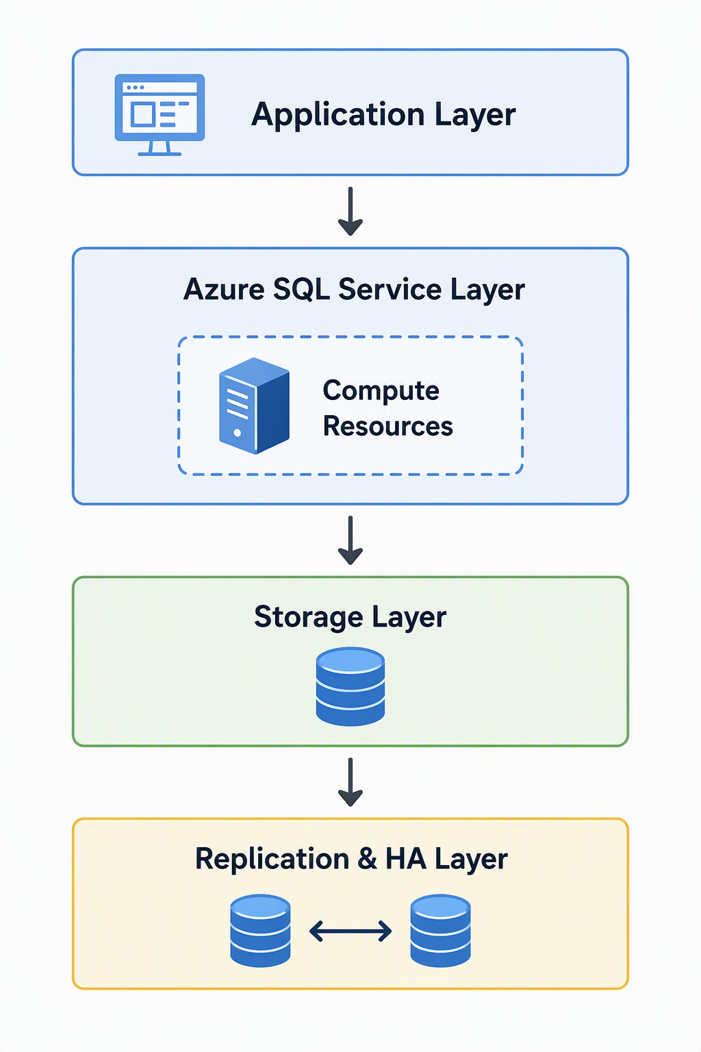

Core Features of Azure SQL
- High Availability
- Automated Backups
- Scalability
- Security
Performance Optimization
Deployment Models
  - Single Database
  - Elastic Pool
  - Serverless
Service Tiers
- General Purpose
- Business Critical
- Hyperscale
Azure SQL & AI
Benefits of Azure SQL
- Fully managed service
- Enterprise-grade security
- Automatic backups & patching
- Built-in disaster recovery
- Global scalability
- Pay-as-you-go pricing
- High availability SLA
- AI-ready database capabilities
- Seamless Azure ecosystem integration
- CosmosDB
It is Microsoft’s globally distributed, fully managed database service designed for modern cloud-native applications. It supports NoSQL, relational, graph, key-value, vector, document workloads while providing global distributions, automatic scaling, low-latency access, & enterprise-grade availability.
Why Azure CosmosDB?

Core Architecture
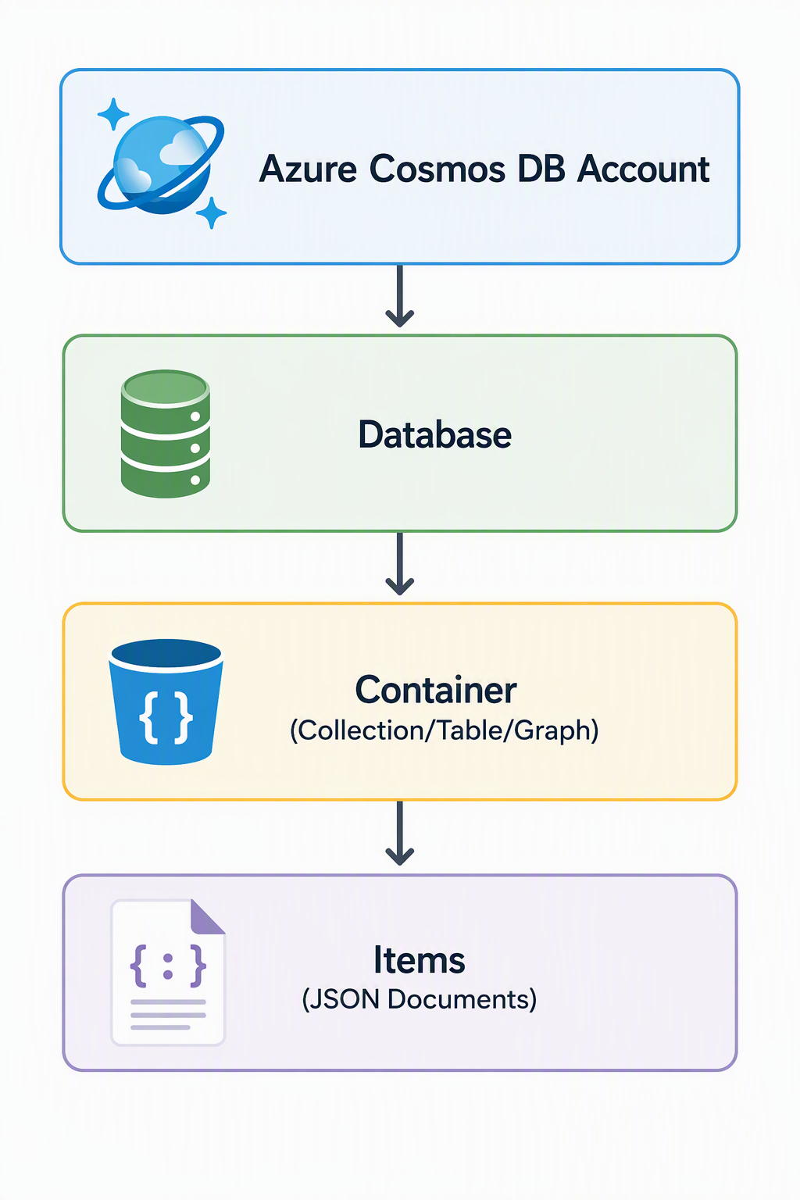
  - Azure CosmosDB Account – Top-level management boundary.
  - Database – Logical grouping of containers
  - Container – Most important scalability unit.
  - Item – Individual JSON document stored in the container.
Multi-model Database Support
- API for NoSQL
- API for MongoDB
- API for Cassandra
- API for Gremlin
- API for Table (Storage)
- PostgreSQL Support
Consistency Levels
- Strong Consistency – guarantees latest committed data.
- Bounded Staleness – Allows small delays between replicas.
- Session Consistency – Default consistency level. Guarantees consistency for an individual user session.
- Consistent Prefix – Reads never see out-of-order updates.
- Eventual Consistency – Data eventually becomes consistent across regions.
AI & Vector Search
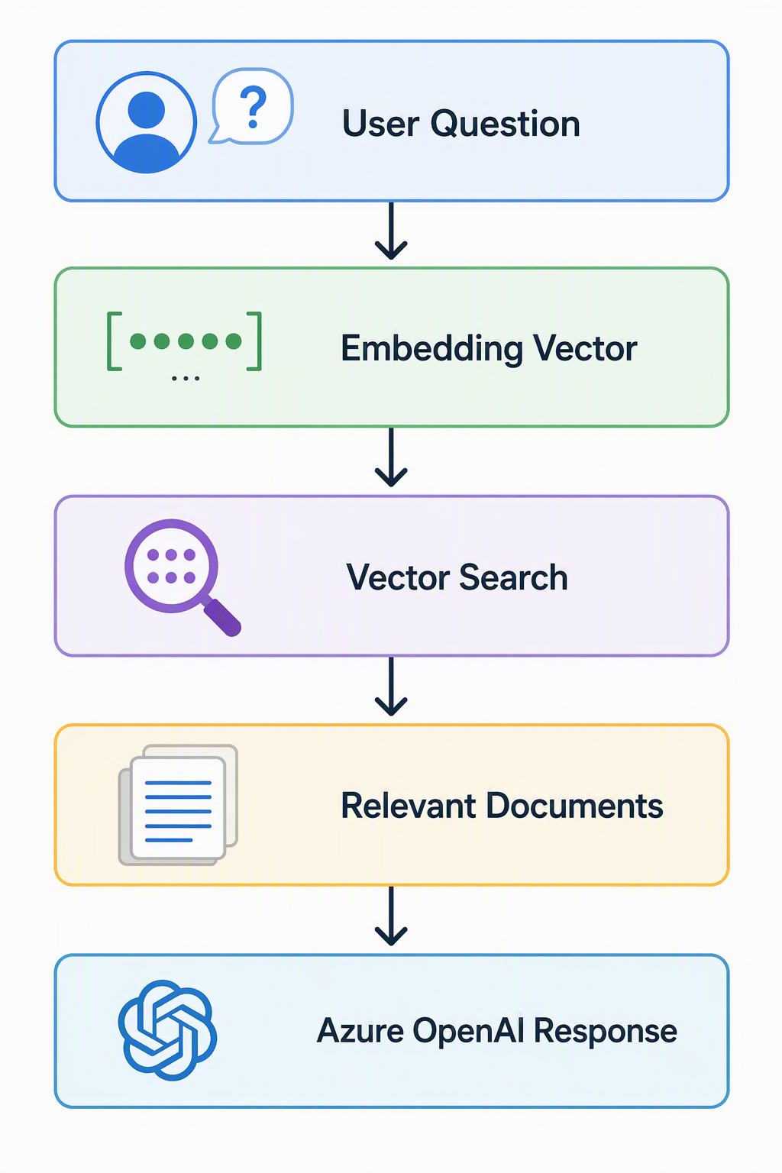

Azure CosmosDB vs Azure SQL Database
Feature | Azure Cosmos DB | Azure SQL Database
Database Type | NoSQL / Multi-model | Relational SQL
Schema | Flexible | Structured
Global Distribution | Native | Supported but not primary design
Scalability | Horizontal | Vertical + Horizontal
Latency | Single-digit ms | Low latency
Partitioning | Automatic | Limited
AI Vector Support | Native | Available but not core
Ideal For | Massive scale cloud apps | Transactional business apps

- Azure SQL vs Cosmos DB (when to use)

Use Azure SQL Database when:
✅ Data is highly structured (tables, rows, relationships)
✅ You need ACID transactions
✅ Complex joins are required
✅ Existing SQL Server knowledge exists
✅ Reporting and analytics are important
✅ ERP, CRM, Finance, HR, Order Management systems
✅ Data consistency is more important than extreme scalability

Use Azure Cosmos DB when:
✅ Data structure changes frequently
✅ Massive horizontal scaling is needed
✅ Global users require low latency
✅ Application handles millions of users
✅ JSON/document-oriented data
✅ IoT, gaming, social media, real-time apps
✅ Multi-region active-active architecture
✅ AI/vector search workloads

